**HOMEPAGE CHHAPAI CONTENT**

***BANNERS***

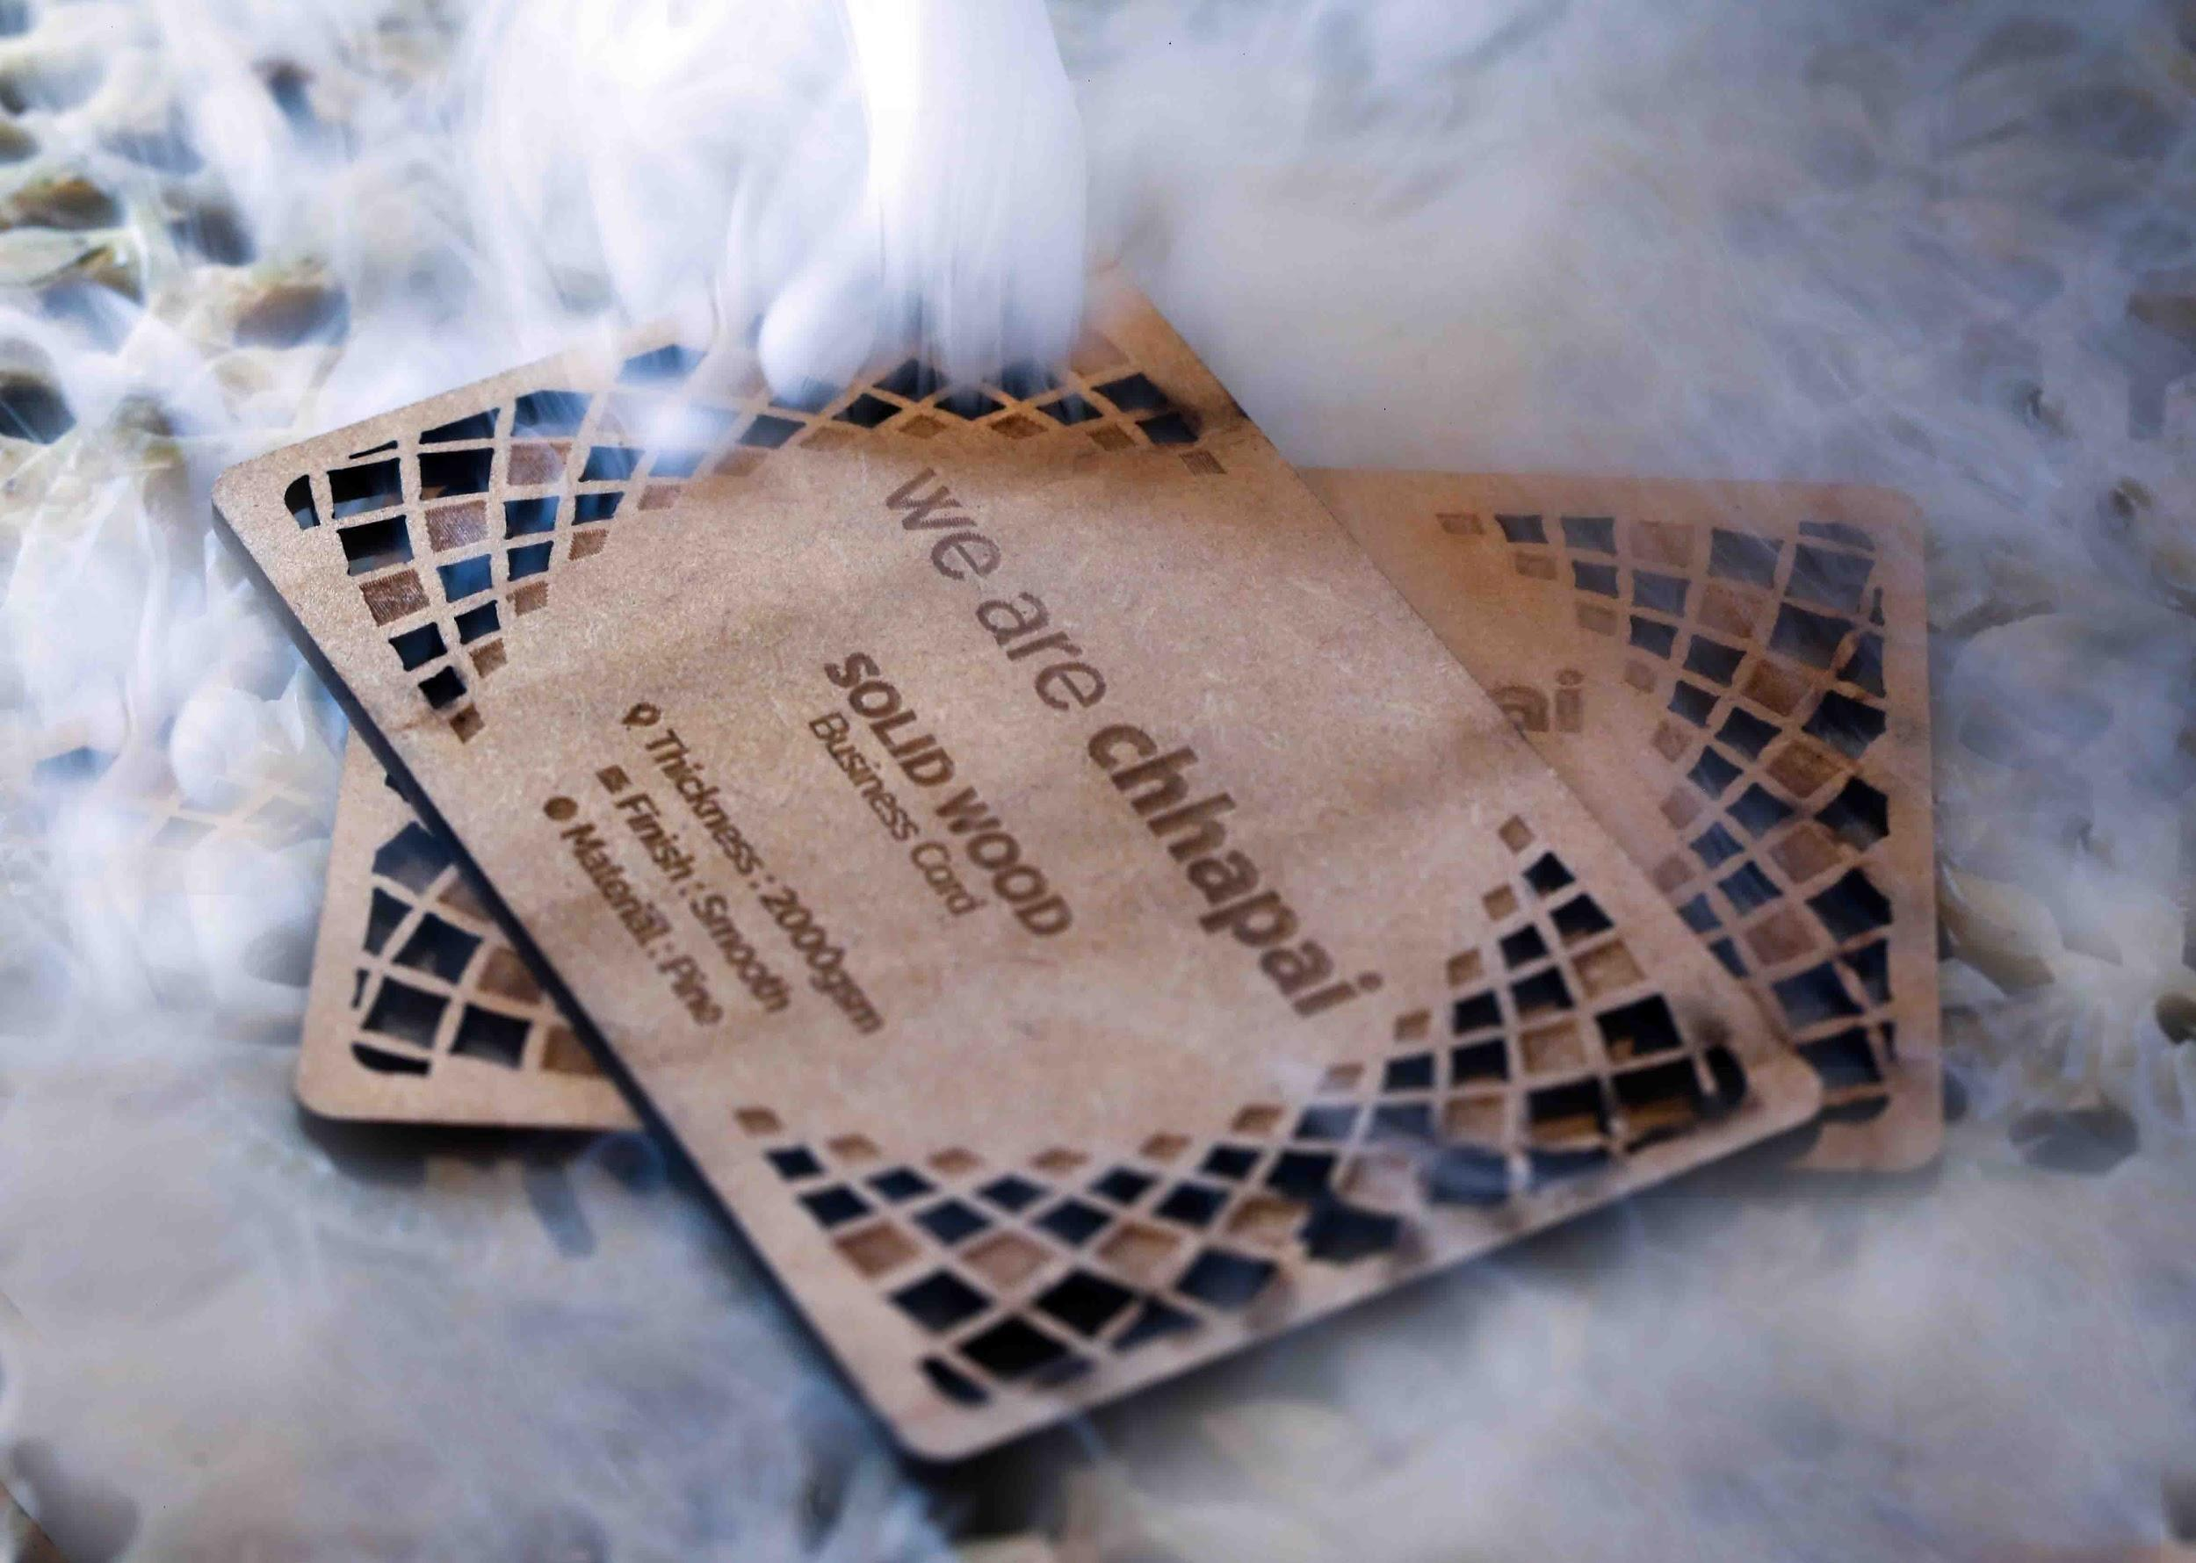

**HEADING**- **QUALITY & CRAFTSMANSHIP**

**SUBHEADING**- Finest wooden cut Business Cards instrumenting the poetic craftsmanship.

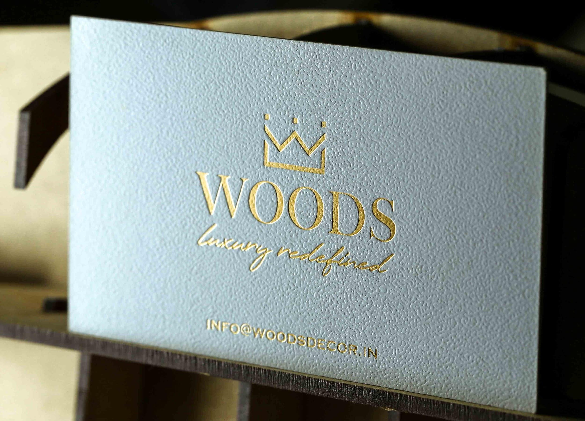

**HEADING**- **BE AT THE FOREFRONT WITH FOIL PRESS**

**SUB-HEADING-** Honeypot the core information with foil press.

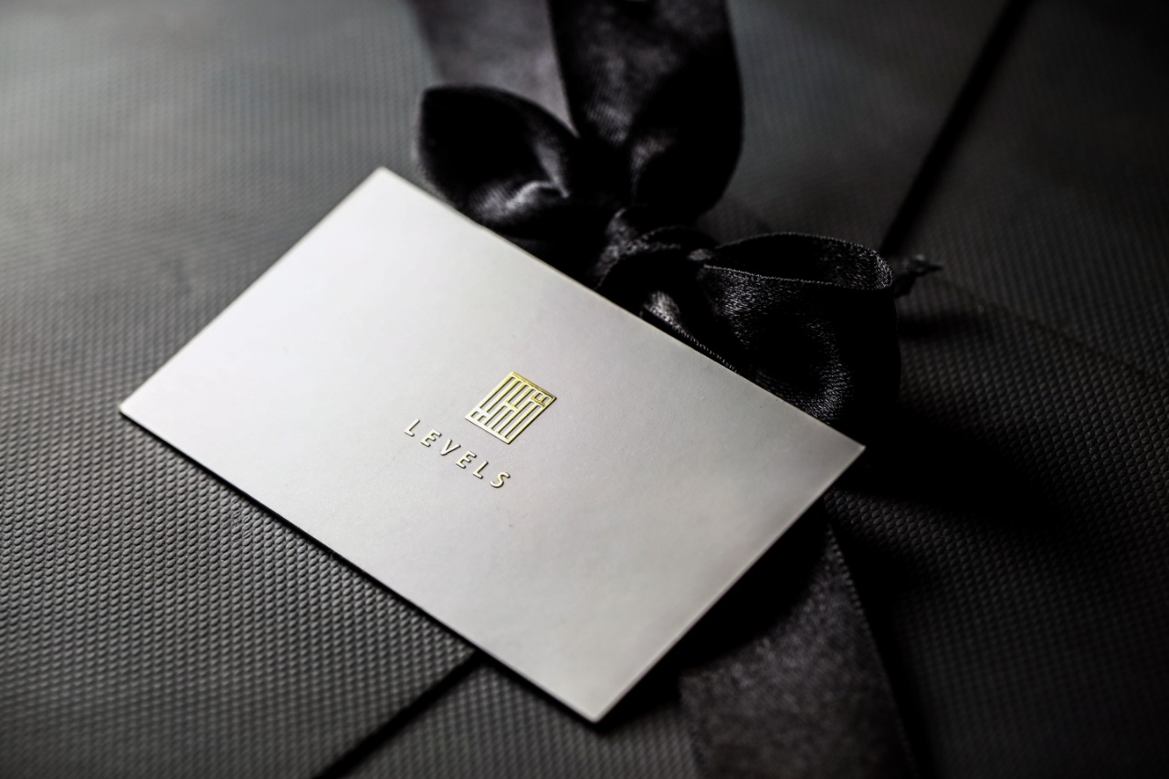

**HEADING**- **WANT YOUR BRAND TO SPEAK COSMOPOLITAN?**

**SUB-HEADING**- Sculpted to be chic, elegant & unlike any other.

IMAGE-4

**HEADING- CLASSY SAMPLE PACK**

**SUB-HEADING**-Relish yourself with new expressions in printing.

IMAGE -5

**HEADING- INFUSING A HINT OF YOUR PERSONALITY IN YOUR BRAND**

**SUB-HEADING -** Let your traits add colours to your brand. Unbox your creative Stationery box.

***PICK THE PERFECT PAPER***

Pocket a paper of your desired texture & design it to perfection & instrument a custom business card.

**PREMIUM PAPER-** Enfolded withLuster-finish, Low-gloss, Luxurious Textures

**TAILOR-MADE-** Fancy something different? Get custom Business Cards as per your zest.

**SENSIBLE-CHOICE-**Providing you with a better choice for you and the planet. Get an environmental friendly visiting card.

**BESPOKE-**Yearn for the right colours for your brand? Let the Business Card speak for your brand.

***MODEL YOUR CREATIVE BUSINESS CARD DESIGN***

Tailor your card rooted to your prospect.

**EMBOSSING-** Get your intricate details be the focal point. Get it embossed with sublime designs. Say it loud with your card.

**ELECTROPLATING-** Create a centerpiece to represent you & your brand. Stand out of the crowd. Get electroplated visiting cards & earn yourself a spotlight.

**LETTERPRESS-** A timeless classic, elegant & graceful design. Attain a classic of Business Cards for the old craftsmanship in you.

**SPOT UV-** Need a dazzling card to cabinet your persona? Taking artistry to another level with awe-inspiring & startling designs.

**FOIL PRESS-** Planning something sensational? Get it engraved with foil press and let the world know.

**EDGE PAINT-** Want to contour your visiting card? Want it to have a rustic outline? Create the border in Gold, Silver & Copper as per your requisite.

**PICK YOUR CHOICE**

(TEMPLATE SECTION)

GET BUSINESS CARDS ONLINE

AT YOUR DOORSTEPS

YOUR EMAIL ADDRESS...

KEYWORDS

* Business Cards
* Custom Business Cards
* Visiting Cards
* Business cards design
* Creative business cards
* Business cards online
* Environment
* Quality